Email Configuration using the email template and PA flow
10 October 2025
11:22
- Email Template -
- Used for drafting email with dynamic values which can be used for multiple scenarios .

- Scenario - Using the email template for sending the email to the user for agreement renewal using the PA flow.

- Entities evolved -
- Agreement
- service account
- Primary contact (of service account)

- Limitation-
  - Email template can't dynamically map the fields from multiple entities.

- Solution -
  - Use the static value and replace them dynamically in PA flow using the expression.

- Implementation -
- Create email template save it in Environment variable using the Guid of the email template
- Fetch the email template in PA flow using the get a row by ID.
- Get the body of email and store it in compose.

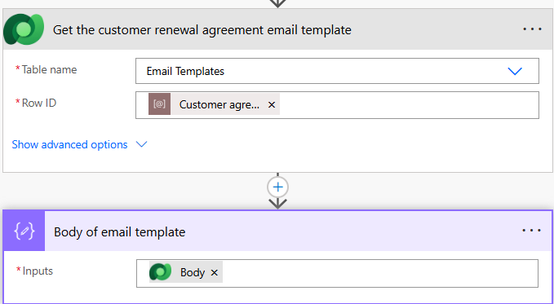

- Also get the Env. variable of agreement due date i.e is one here and a text and convert it to integer

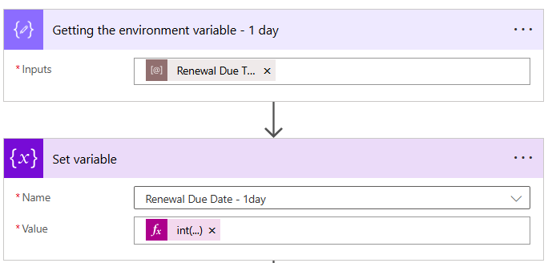

- Email Template -
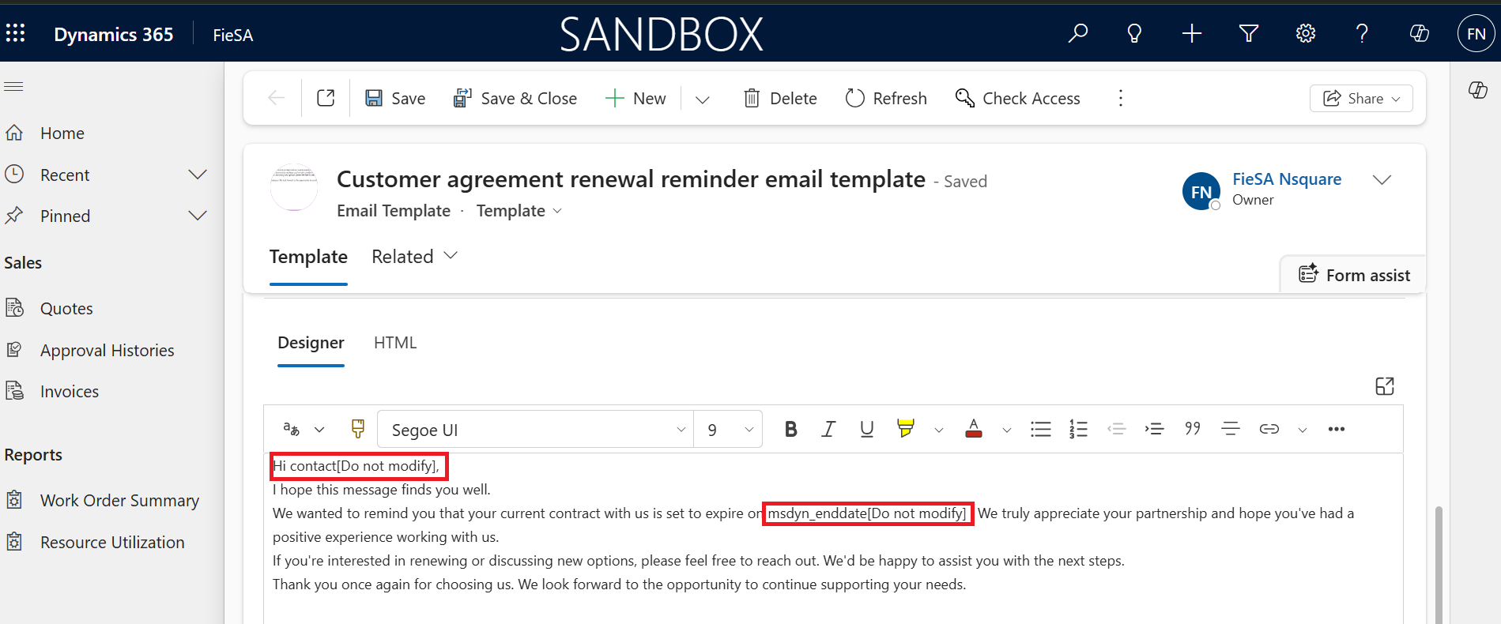

- Expression to replace dynamic values from email template .
replace(
replace(
replace(
outputs('Body_of_email_template'),
'contact[Do not modify]',
outputs('Get_the_primary_contact_of_service_account_')?['body/firstname']
),
'msdyn_enddate[Do not modify]',
outputs('_Update_the_renewal_status_to_renewal_due_2')?['body/msdyn_enddate@OData.Community.Display.V1.FormattedValue']
),
']]>',''
)

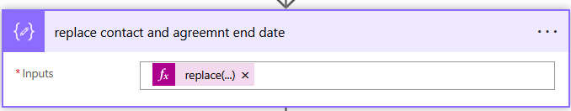

- Use it in email body - description

Also check this for single entity in email template

Refrences

-flow for email configuration -
Quote - Sending Email Regarding quote approval status

https://make.powerautomate.com/environments/293141dd-81eb-e77c-b664-dc20b516931d/solutions/8f070a08-7d09-f011-bae2-000d3a5bb13e/flows/c55c8b75-23c6-45d3-a355-332b9719ebb6?utm_source=solution_explorer&v3survey=true&v3=false

Here body of email template is instantiated with perform a bound action -

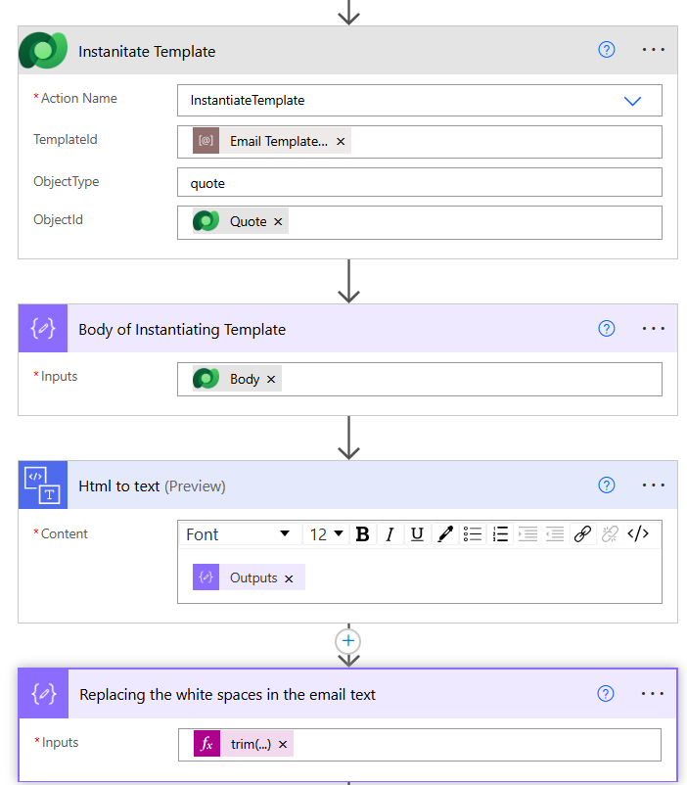

Trim body -

trim(
replace(
replace(
replace(
replace(
replace(
replace(
string(outputs('Html_to_text')?['body']),
'\n', ' '
),
'\r', ''
),
'\t', ''
),
'*', ''
),
'nsq_comments',
string(triggerOutputs()?['body']?['nsq_comments'])
),
'nsq_internalapproverid',
string(outputs('Fetching_the_Name_of_the_Team'))
)
)

- Dynamically insert url of record

- Step one - get model driven id

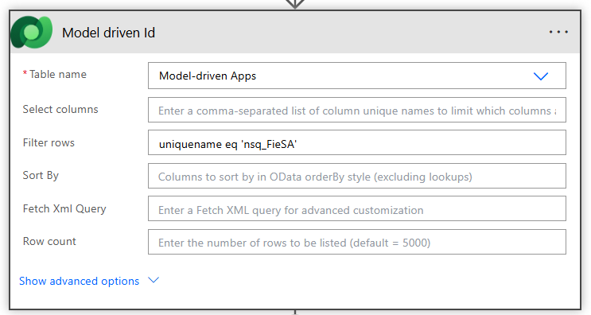

2.Get a booking record id -
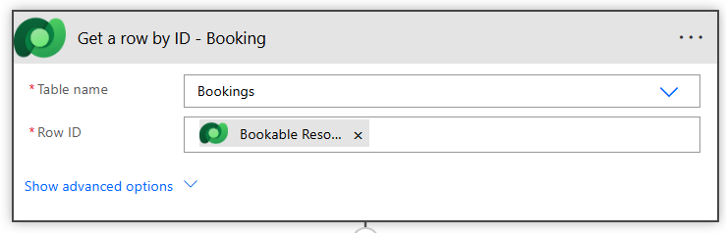

3.get cancelled booking url -

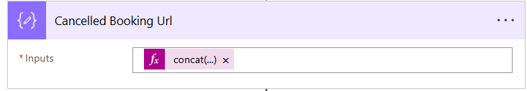

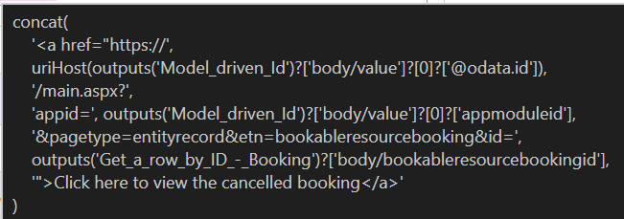

- Another way of configuring the email - for a team
1.declare variable recipent
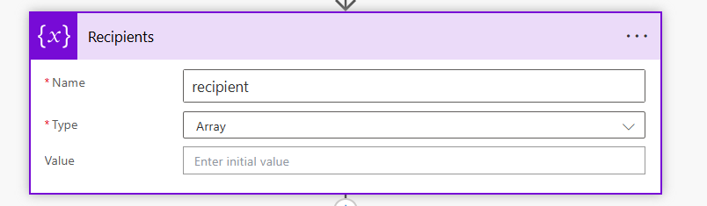

- Add
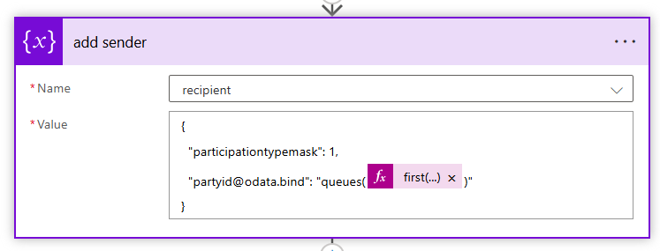

- Append to an array variable
- Here multiple users are added to To

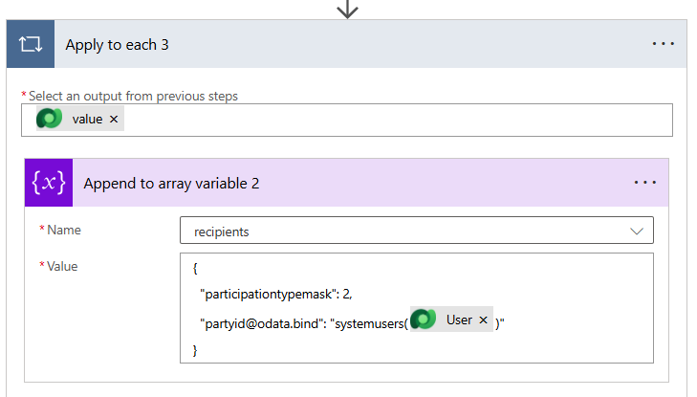

- Add appended variable to recipent to the activity party
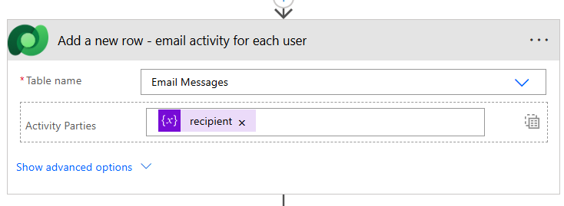

  - Email instance create from email template

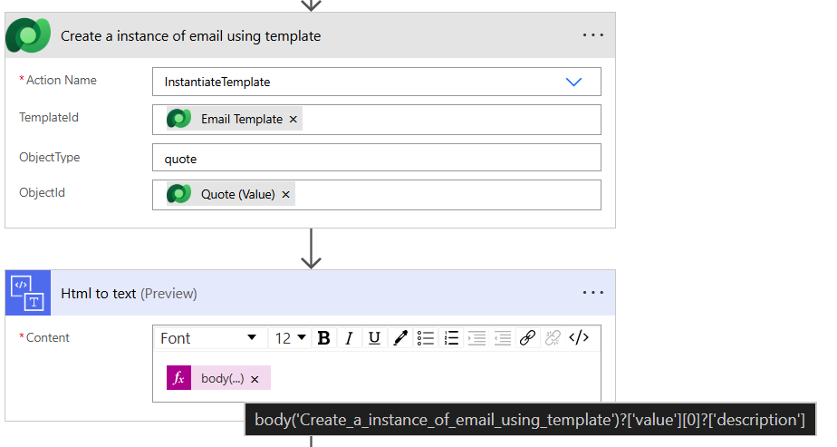

Send email with the options

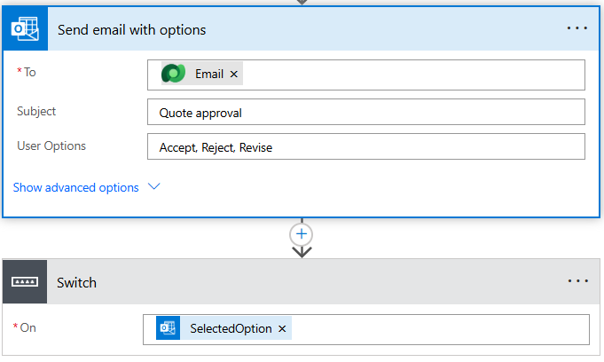

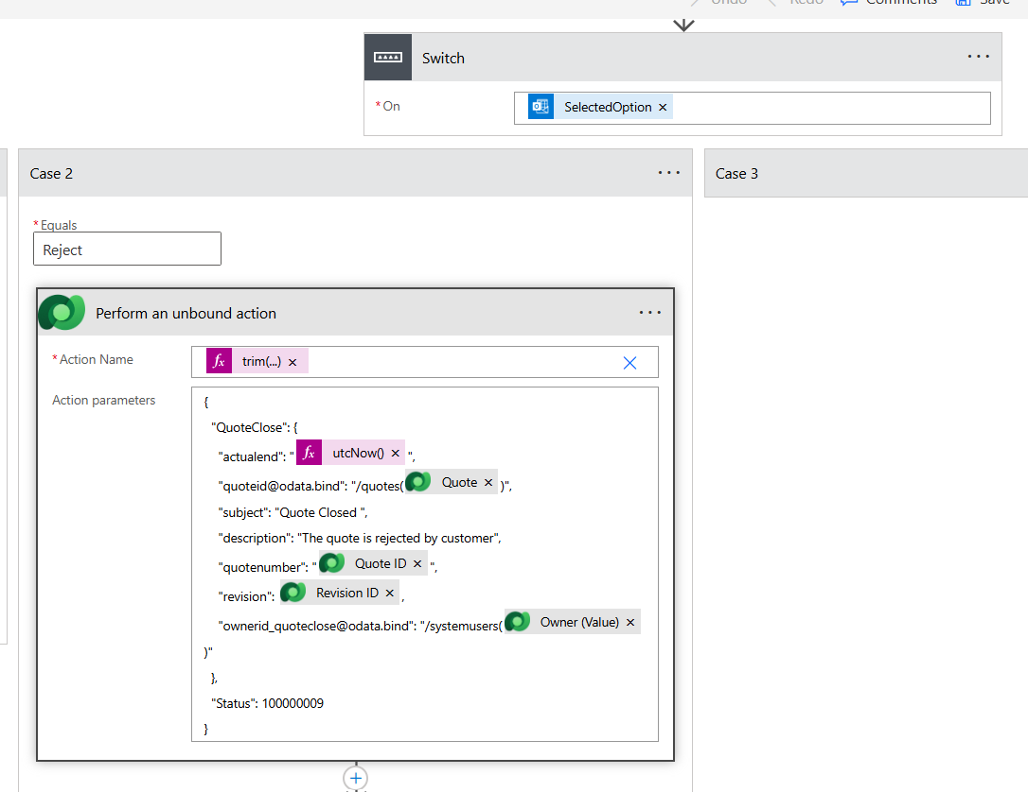

Perform unbound action for closing the quote -
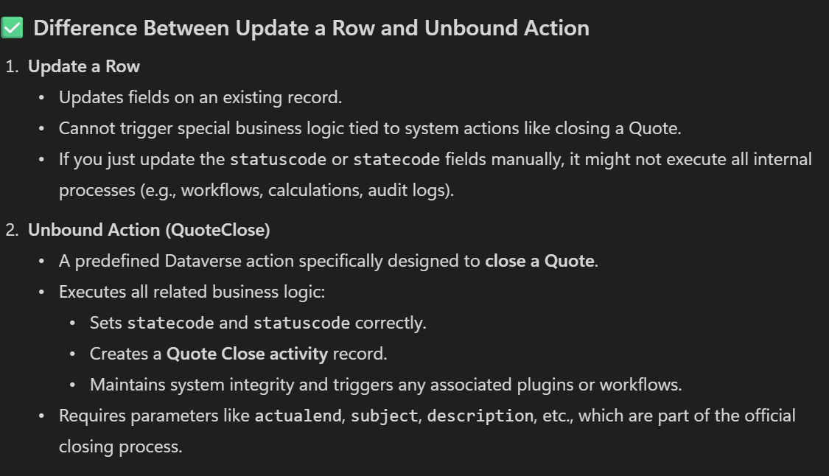

Use the dynamic email template for populating the email
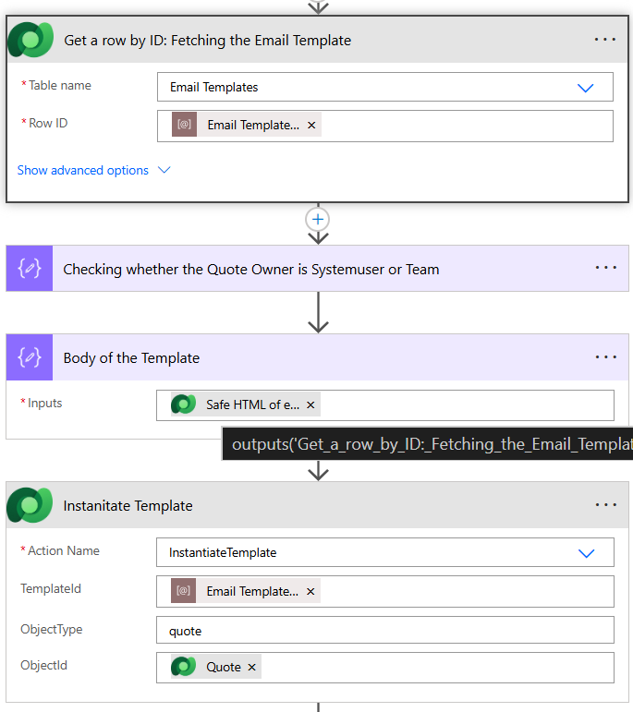

2.
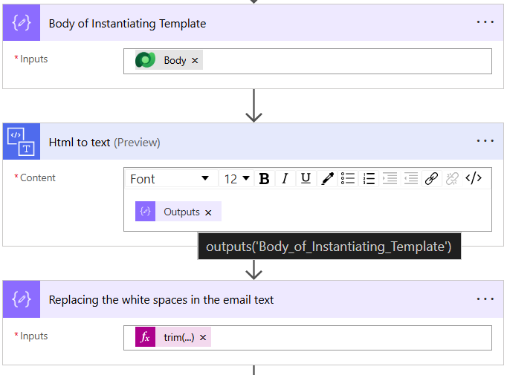

Configuring try catch in PA
17 October 2025
16:28

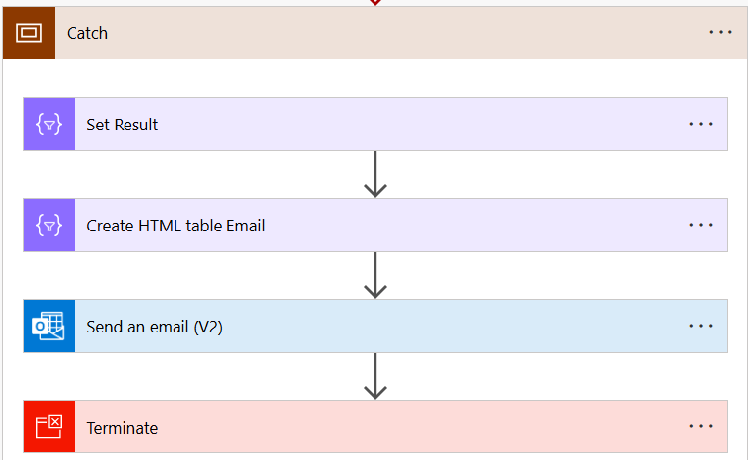

Set Result -

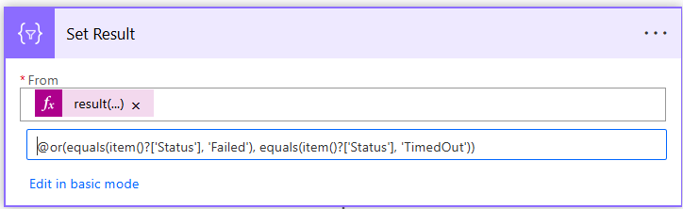

Create HTML table Email -
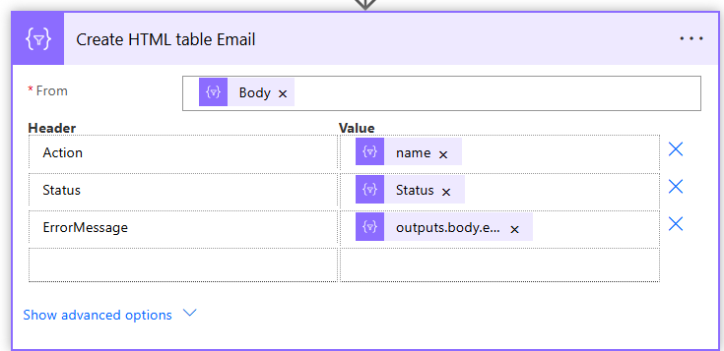

Send an email -
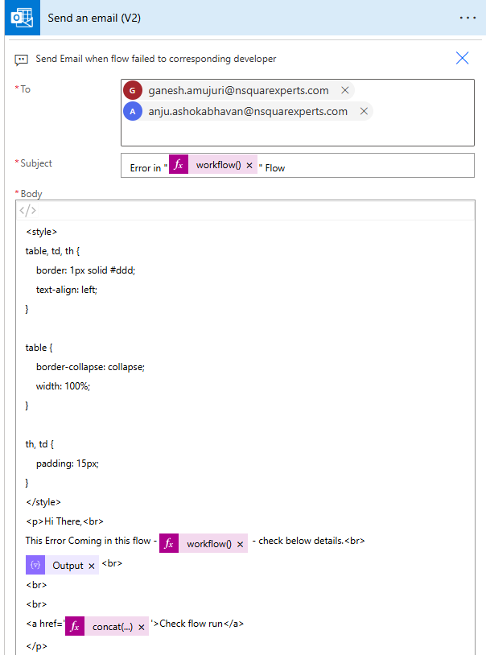

Email Draft -
<style>
table, td, th {
border: 1px solid #ddd;
text-align: left;
}
table {
border-collapse: collapse;
width: 100%;
}

th, td {
padding: 15px;
}
</style>
<p>Hi There,<br>
This Error Coming in this flow - @{workflow()['tags']['flowDisplayName']} - check below details.<br>
@{body('Create_HTML_table_Email')}<br>
<br>
<br>
<a href='@{concat('https://make.powerautomate.com/environments/', workflow()?['tags']['environmentName'], '/flows/', workflow()?['name'], '/runs/', workflow()?['run']['name'])}'>Check flow run</a>
</p>

Catch configure run after -
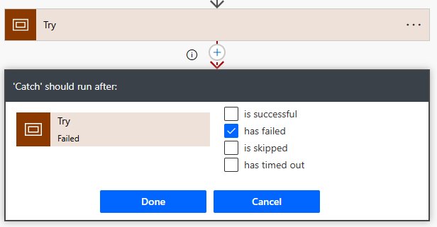

Miscelleneous
24 October 2025
14:44

Concat multiple links -
1.
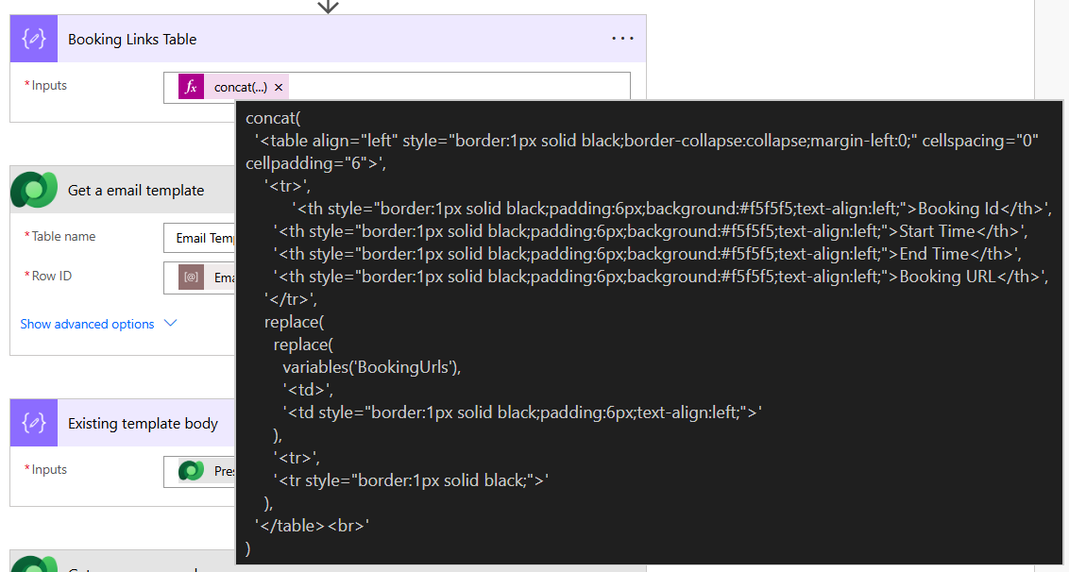

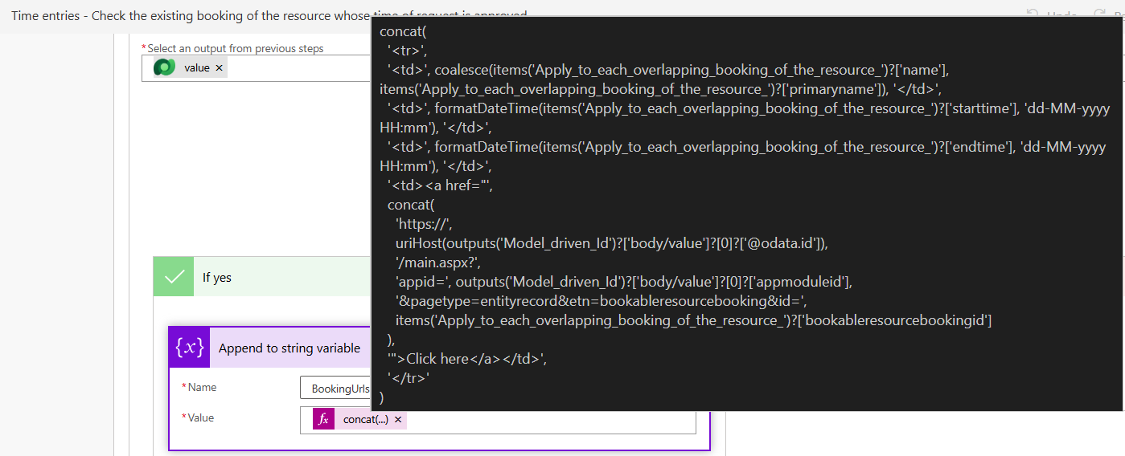

3.
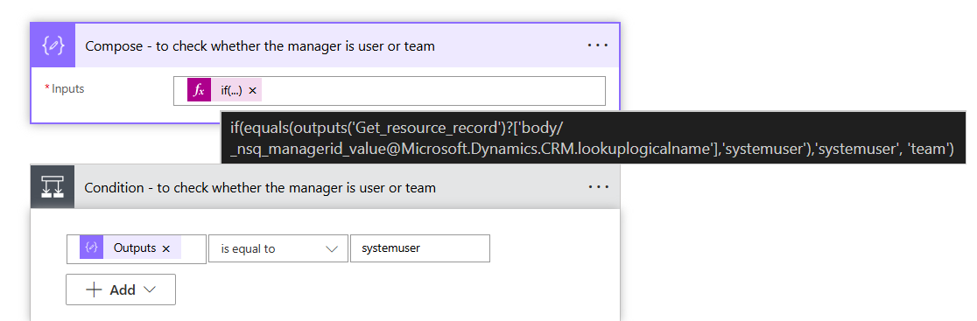

Get file content using path -

